CS Bridge Module 22 Intro to OS

1. Week 12 Module 22 Intro to OS

1.1 CS Bridge: Intro to Operating Systems
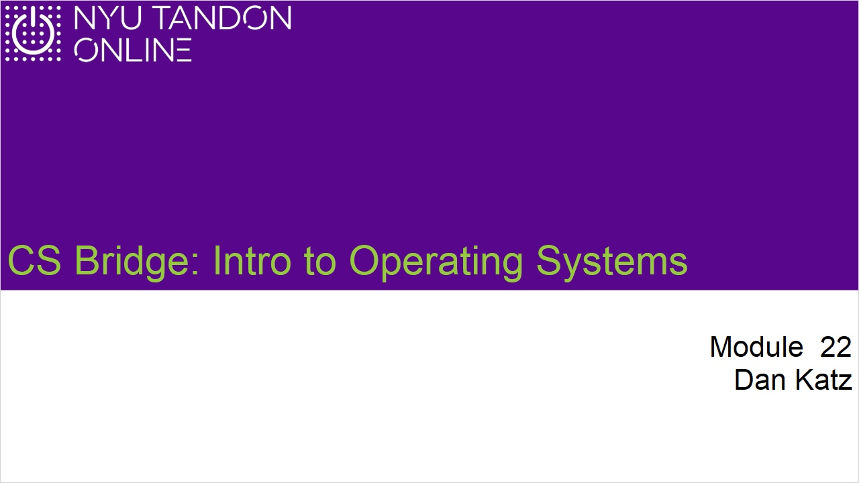
Notes:

1.2 In this module
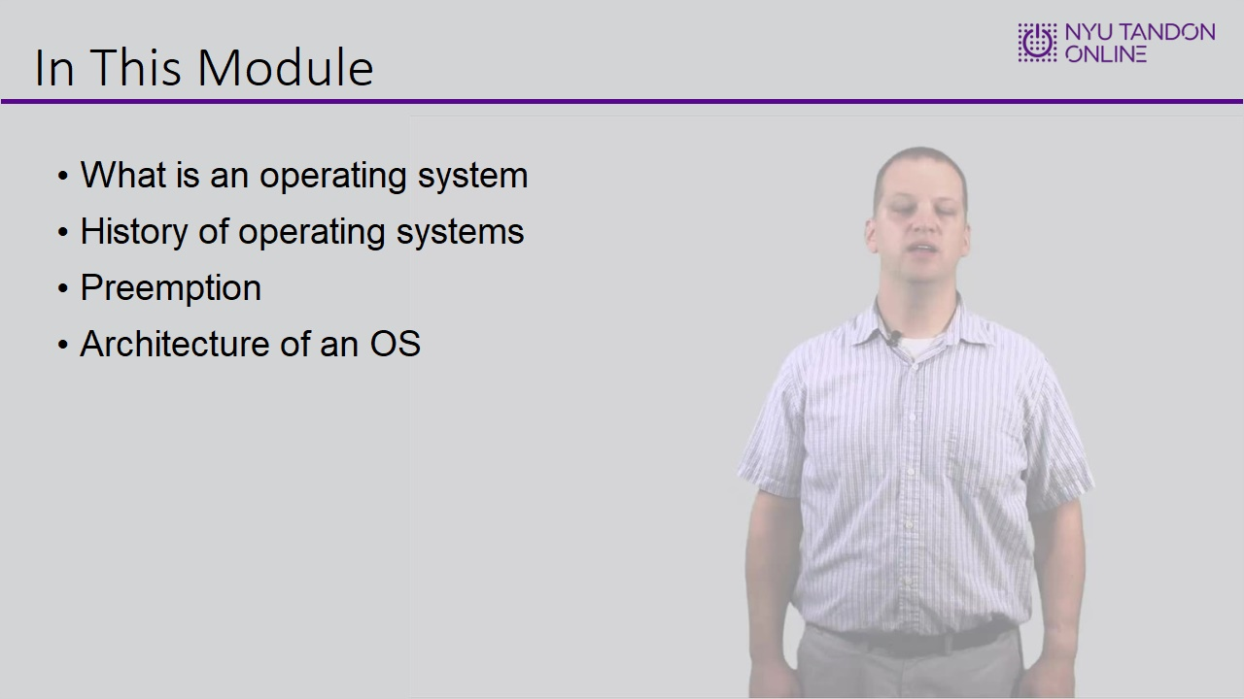

1.3 What is an OS
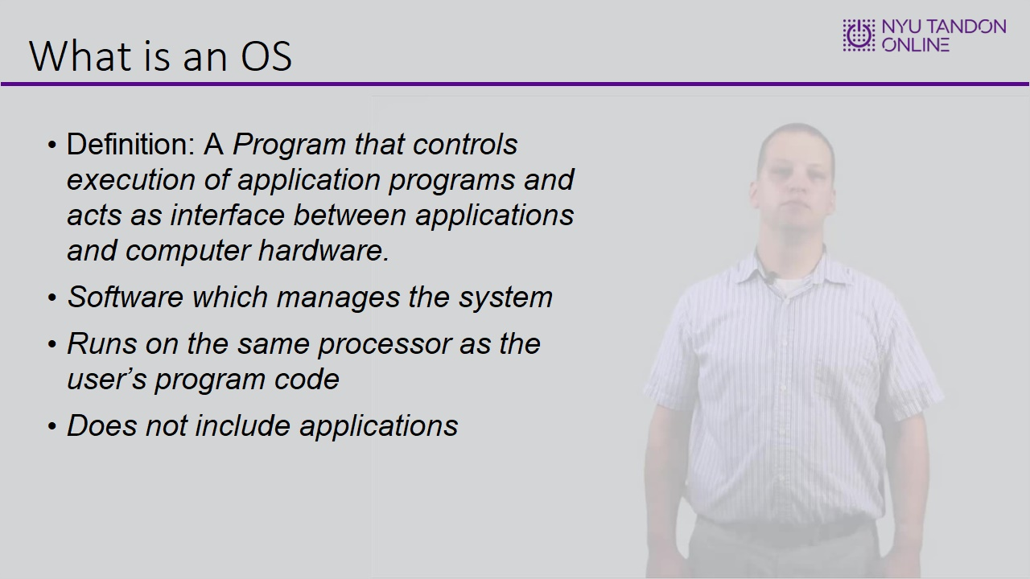

1.4 Layers of Interaction
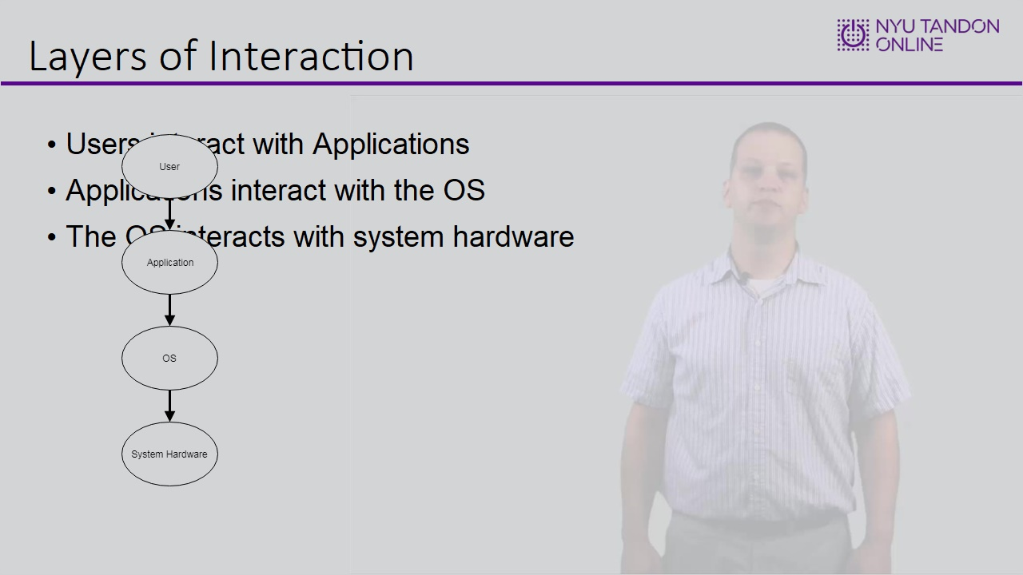

1.5 What you buy in the store
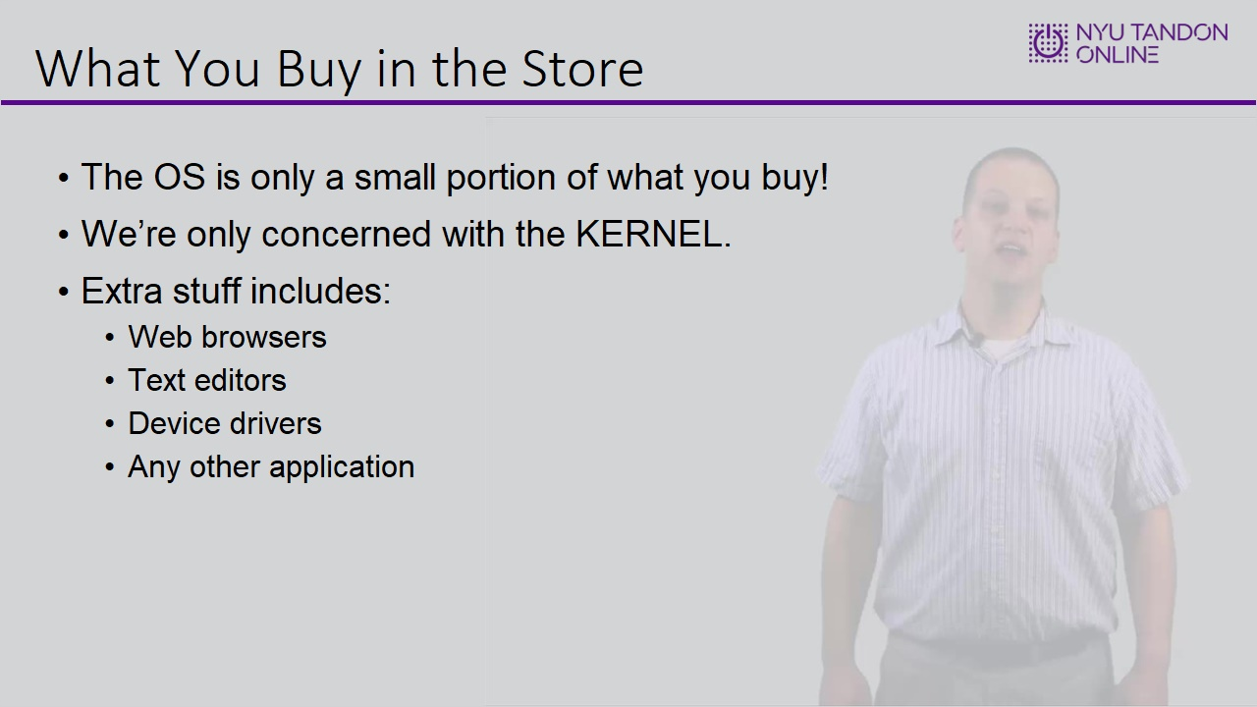

1.6 The OS as a resource manager
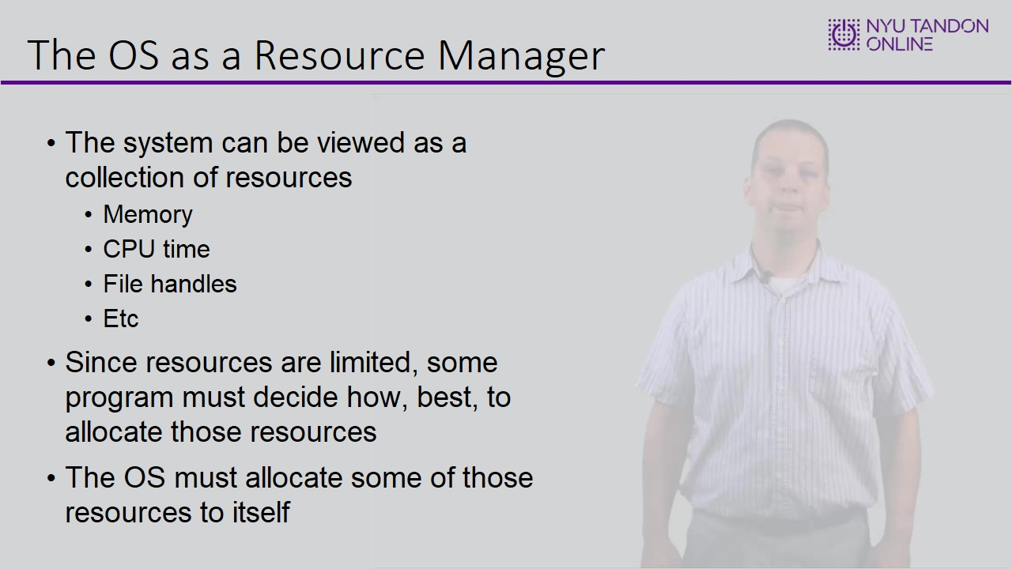

1.7 Back in the olden days
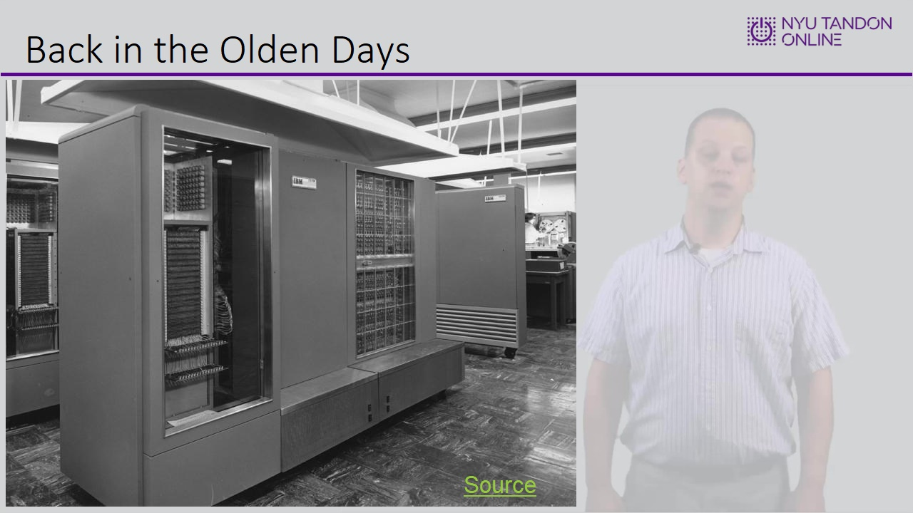

1.8 Today’s environment
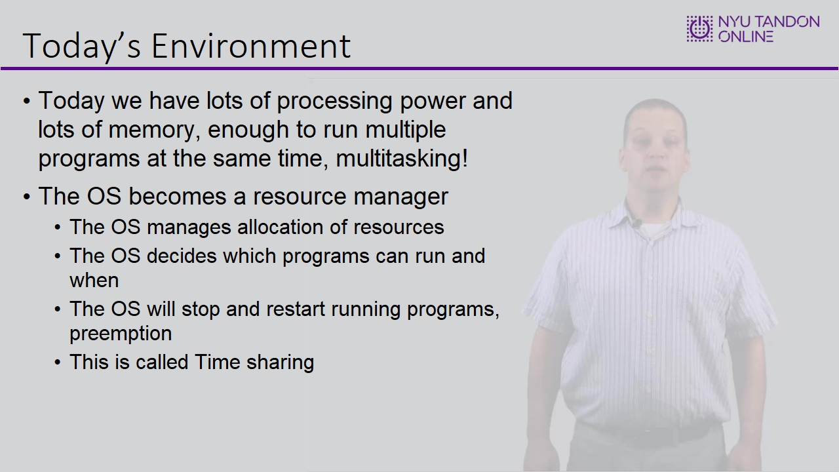

1.9 Monitoring running programs
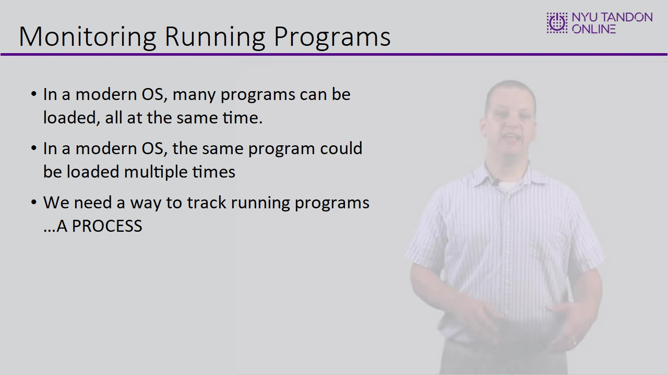

1.10 OS levels
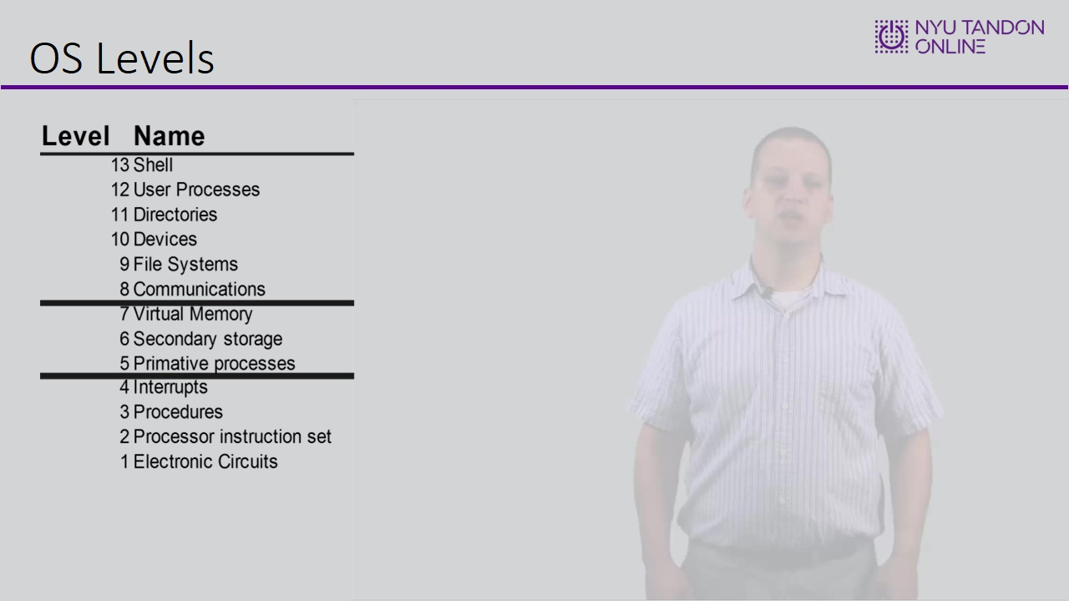

1.11 Knowledge Check
(Drag and Drop, 10 points, unlimited attempts permitted)
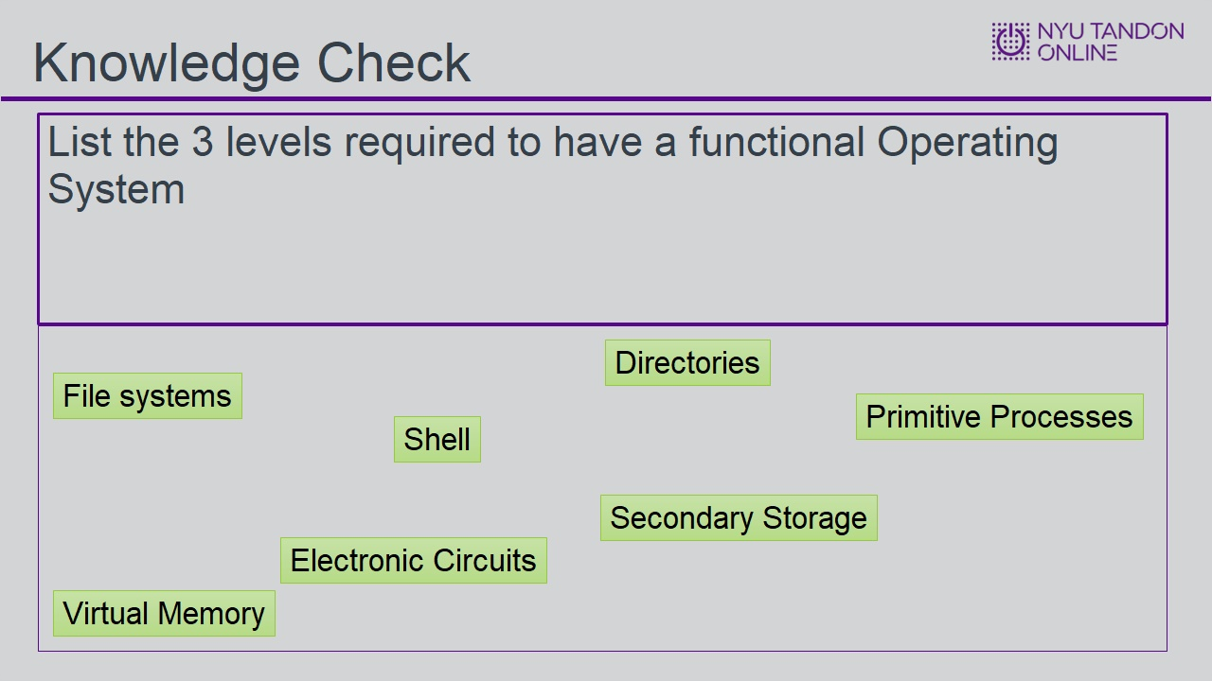
Drag Item | Drop Target
Virtual Memory | List the 3 levels required to have a functional Operating System
Secondary Storage | List the 3 levels required to have a functional Operating System
Primitive Processes | List the 3 levels required to have a functional Operating System
File systems | Rectangle 1
Directories | Rectangle 1
Shell | Rectangle 1
Electronic Circuits | Rectangle 1

Drag and drop properties
Return item to start point if dropped outside the correct drop target
Snap dropped items to drop target (Free)
Delay item drop states until interaction is submitted

Feedback when correct:
That's right! You selected the correct response.
Feedback when incorrect:
You did not select the correct response.

Correct (Slide Layer)
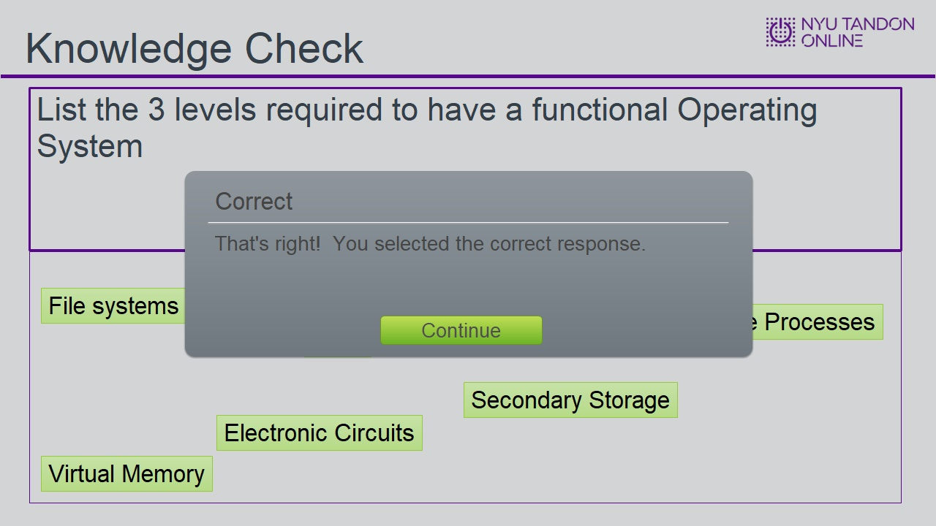

Incorrect (Slide Layer)
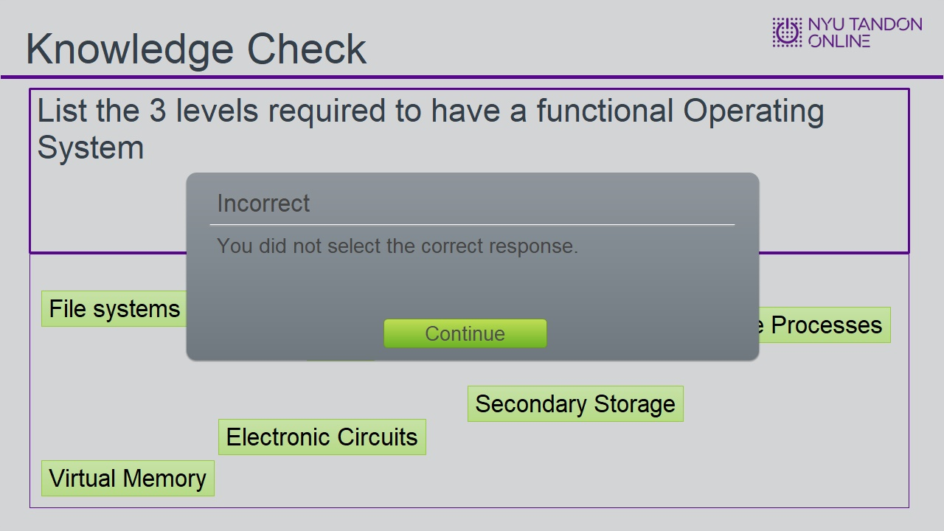

Try Again (Slide Layer)
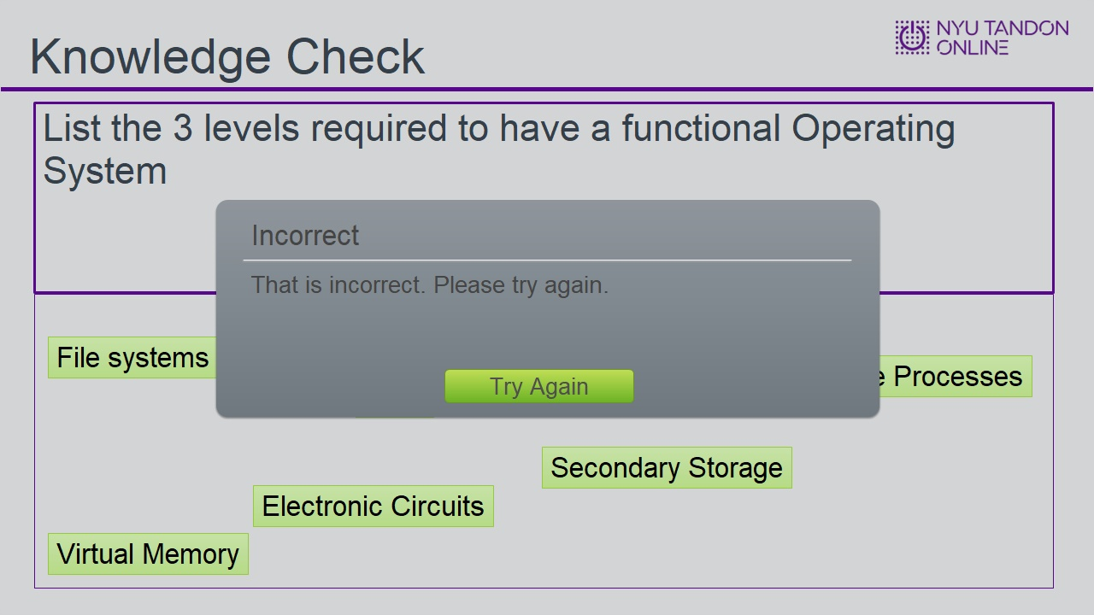

1.12 The windows Model
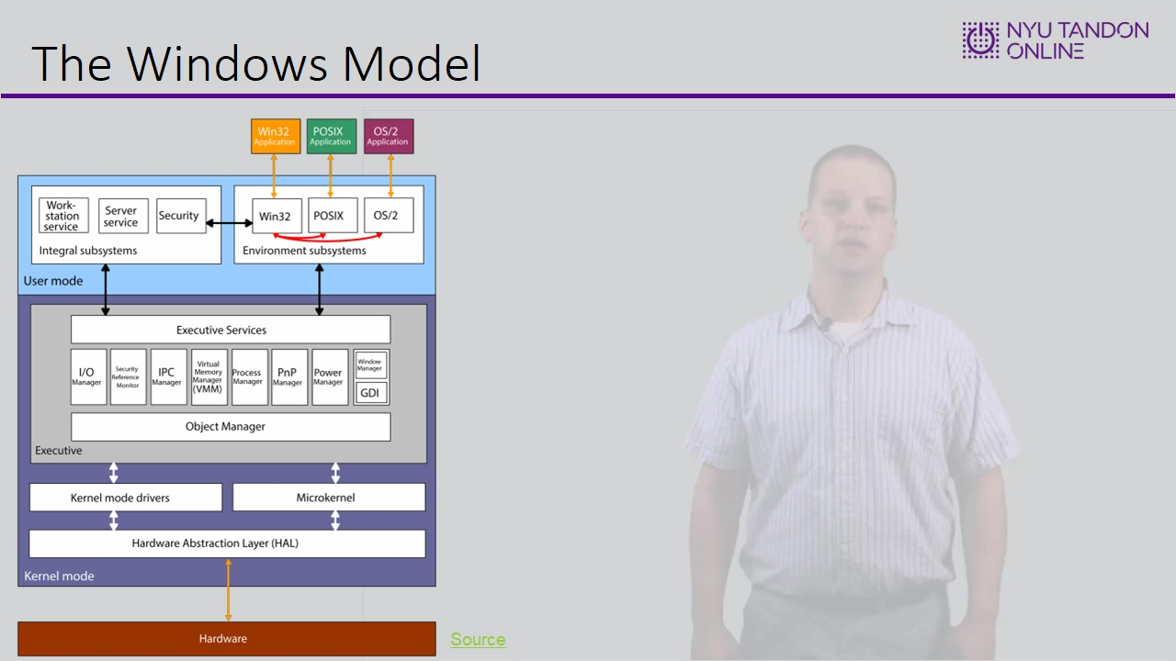

1.13 The HAL
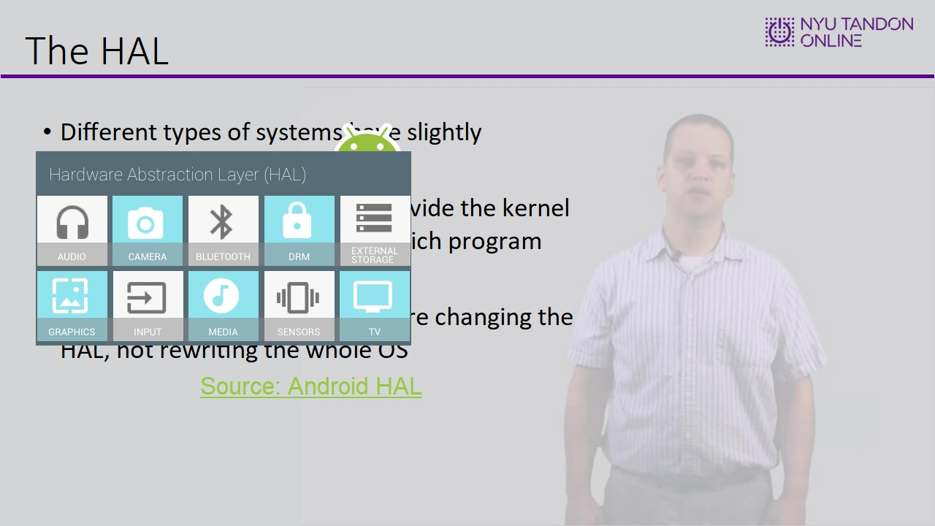

1.14 Knowledge Check
(True/False, 10 points, 2 attempts permitted)
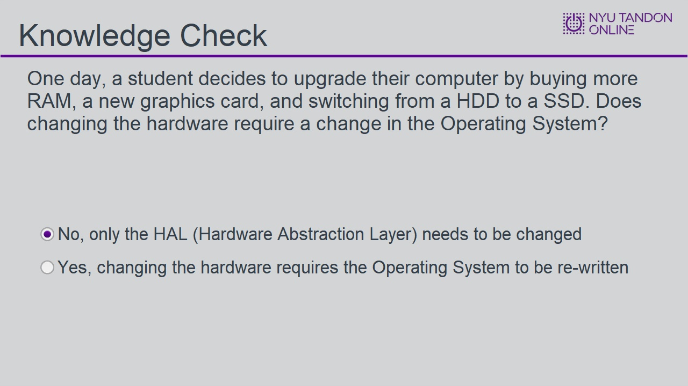
Correct | Choice
X | No, only the HAL (Hardware Abstraction Layer) needs to be changed
 | Yes, changing the hardware requires the Operating System to be re-written

Feedback when correct:
That's right! You selected the correct response.
Feedback when incorrect:
Since the hardware only interacts with one key part of the Operating System, it does not need to be changed!

Correct (Slide Layer)
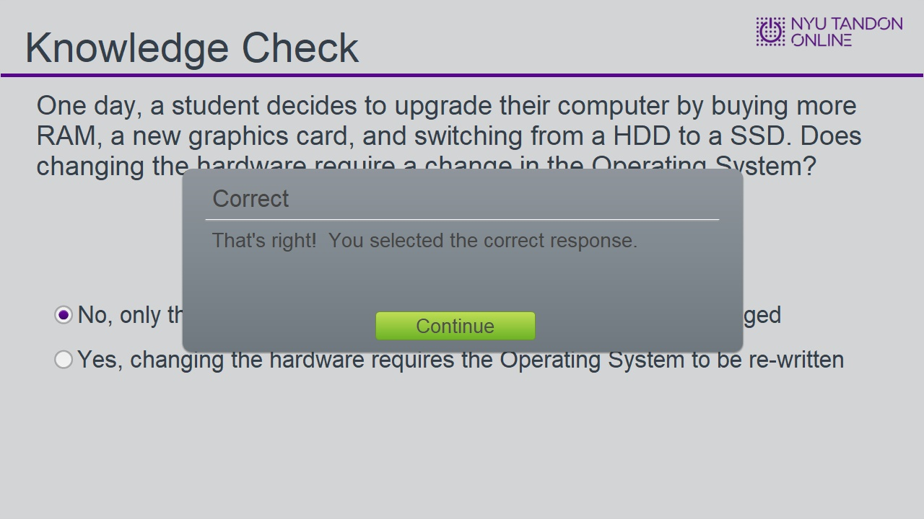

Incorrect (Slide Layer)
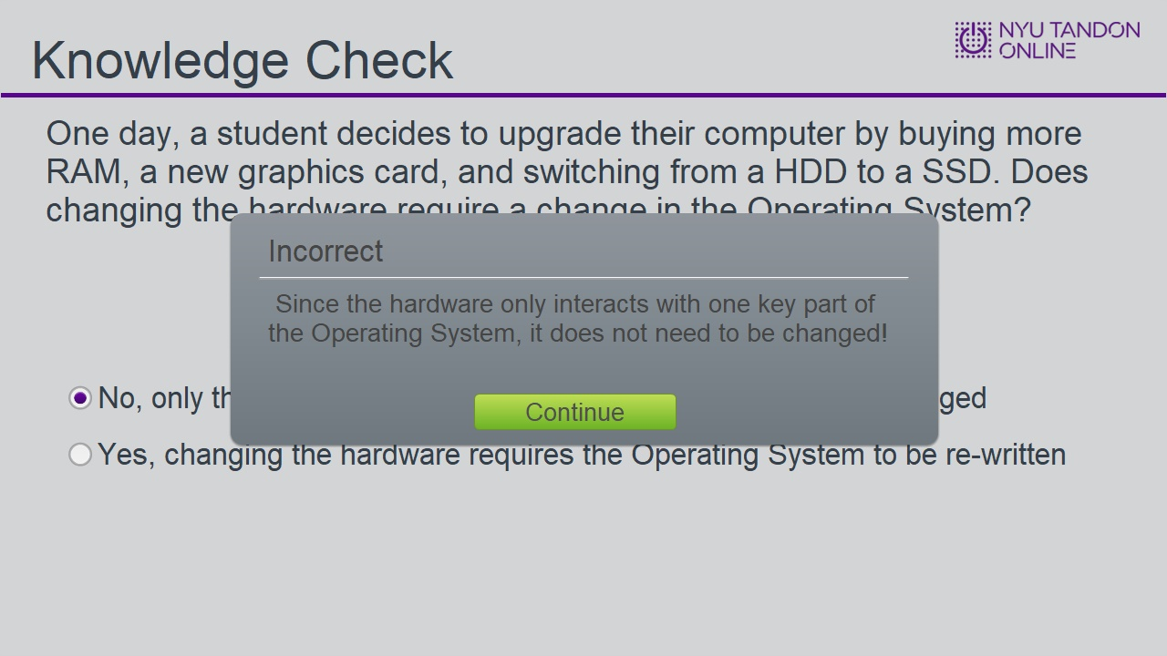

Try Again (Slide Layer)
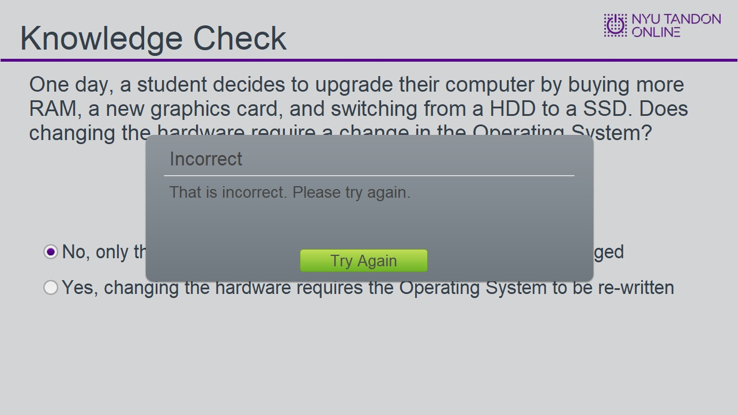

1.15 Windows device drivers
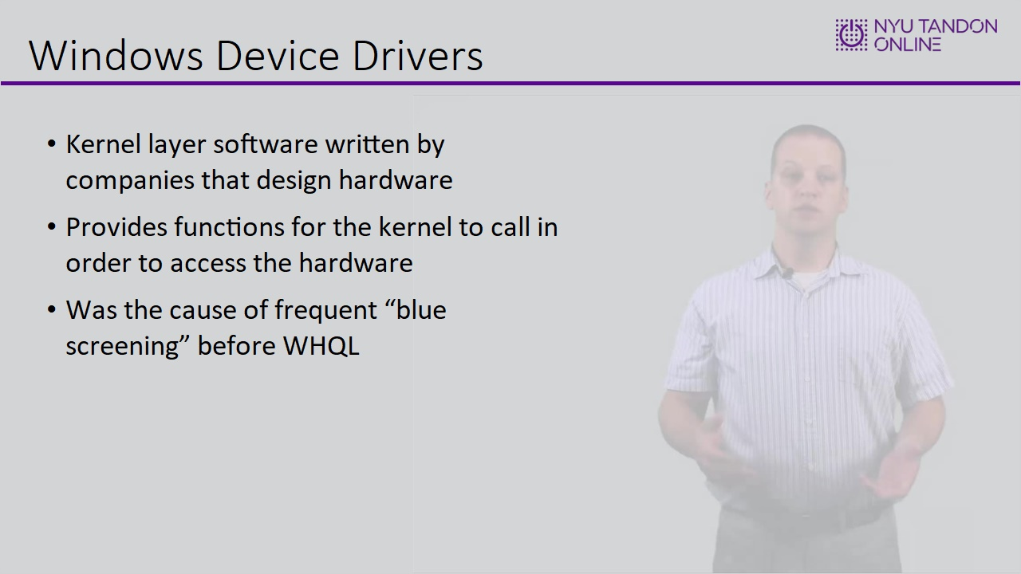

1.16 UNIX
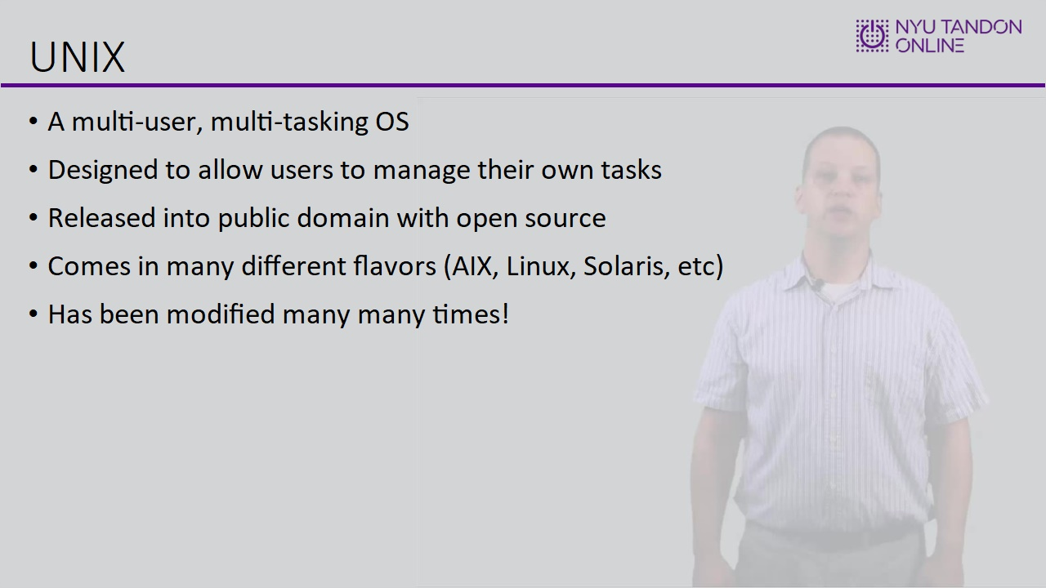

1.17 In this module, we learned
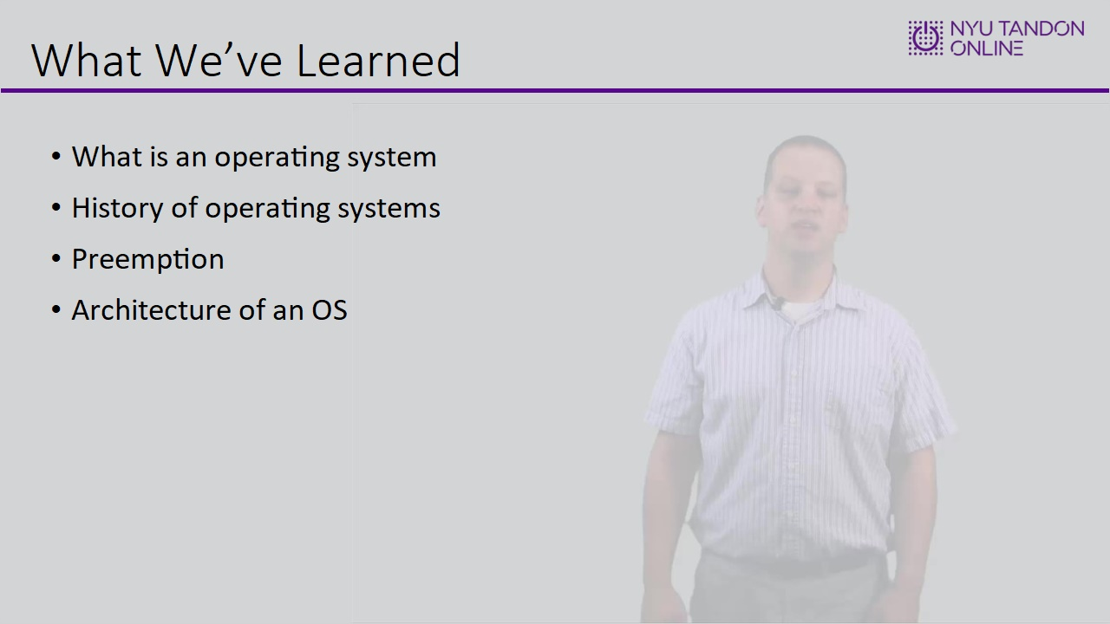

1.18 End of Module
